Twilio

📡 What is Twilio?
# Source: AI Source: Provided by: [Data Path: Persons Table -> ID Column: 1, Name_En Column: Motasem Essam] -> From: [Chatgpt (GPT‑5 Mini)] on [1/21/2026]
Twilio is a cloud communications platform that allows developers and businesses to programmatically send and receive:
- SMS (text messages)
- Voice calls
- WhatsApp messages
- MMS (media messages)
- Video calls
- Email (via SendGrid)
It provides powerful APIs and tools to build communication features into your web, mobile, or desktop applications — without needing telecom infrastructure.

🧩 Core Features of Twilio
# Source: AI Source: Provided by: [Data Path: Persons Table -> ID Column: 1, Name_En Column: Motasem Essam] -> From: [Chatgpt (GPT‑5 Mini)] on [1/21/2026]
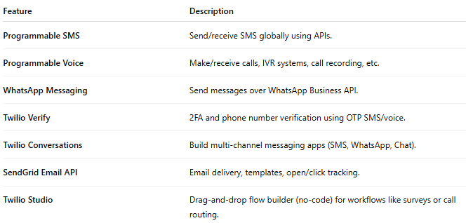

Feature | Description
Programmable SMS | Send/receive SMS globally using APIs.
Programmable Voice | Make/receive calls, IVR systems, call recording, etc.
WhatsApp Messaging | Send messages over WhatsApp Business API.
Twilio Verify | 2FA and phone number verification using OTP SMS/voice.
Twilio Conversations | Build multi-channel messaging apps (SMS, WhatsApp, Chat).
SendGrid Email API | Email delivery, templates, open/click tracking.
Twilio Studio | Drag-and-drop flow builder (no-code) for workflows like surveys or call routing.

💻 Example: Sending SMS Using PHP
# Source: AI Source: Provided by: [Data Path: Persons Table -> ID Column: 1, Name_En Column: Motasem Essam] -> From: [Chatgpt (GPT‑5 Mini)] on [1/21/2026]
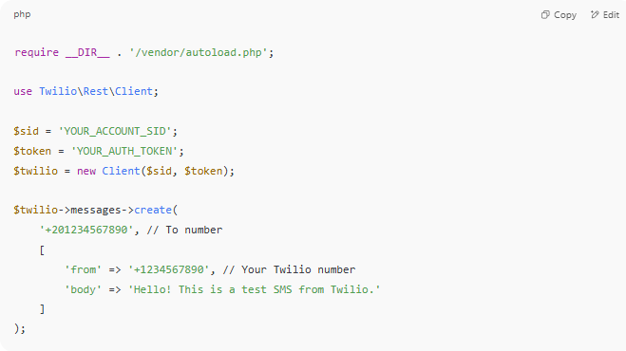

require __DIR__ . '/vendor/autoload.php';

use Twilio\Rest\Client;

$sid = 'YOUR_ACCOUNT_SID';
$token = 'YOUR_AUTH_TOKEN';
$twilio = new Client($sid, $token);

$twilio->messages->create(
'+201234567890', // To number
[
'from' => '+1234567890', // Your Twilio number
'body' => 'Hello! This is a test SMS from Twilio.'
]
);

💰 Pricing
# Source: AI Source: Provided by: [Data Path: Persons Table -> ID Column: 1, Name_En Column: Motasem Essam] -> From: [Chatgpt (GPT‑5 Mini)] on [1/21/2026]
- Pay-as-you-go model.
- Example: $0.0075/SMS (US), higher or lower based on country.
- Free trial: Includes $15+ trial credit and a free virtual phone number.

🌍 Global Reach
# Source: AI Source: Provided by: [Data Path: Persons Table -> ID Column: 1, Name_En Column: Motasem Essam] -> From: [Chatgpt (GPT‑5 Mini)] on [1/21/2026]
- Twilio supports sending SMS to over 180 countries.
- Works with local carrier networks worldwide.
- Offers phone number rental (local, toll-free, short codes, etc.).

🛡️ Use Cases
# Source: AI Source: Provided by: [Data Path: Persons Table -> ID Column: 1, Name_En Column: Motasem Essam] -> From: [Chatgpt (GPT‑5 Mini)] on [1/21/2026]
- OTP and 2FA (Verify API)
- Order & delivery notifications
- Appointment reminders
- Customer service chat systems
- Marketing and mass messaging
- Voice bots / call centers / IVRs

⚠️ Limitations of Twilio Services
# Source: AI Source: Provided by: [Data Path: Persons Table -> ID Column: 1, Name_En Column: Motasem Essam] -> From: [Chatgpt (GPT‑5 Mini)] on [1/21/2026]
While Twilio is powerful and widely used, it has some limitations and constraints, depending on usage, region, and account type.

📌 1. Regional Limitations
# Source: AI Source: Provided by: [Data Path: Persons Table -> ID Column: 1, Name_En Column: Motasem Essam] -> From: [Chatgpt (GPT‑5 Mini)] on [1/21/2026]
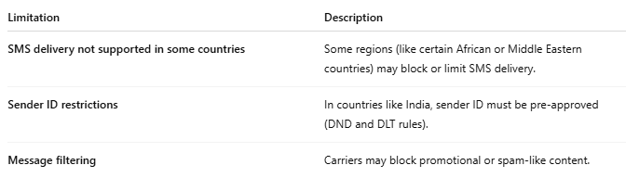

Limitation | Description
SMS delivery not supported in some countries | Some regions (like certain African or Middle Eastern countries) may block or limit SMS delivery.
Sender ID restrictions | In countries like India, sender ID must be pre-approved (DND and DLT rules).
Message filtering | Carriers may block promotional or spam-like content.

📌 2. Account and Trial Limitations
# Source: AI Source: Provided by: [Data Path: Persons Table -> ID Column: 1, Name_En Column: Motasem Essam] -> From: [Chatgpt (GPT‑5 Mini)] on [1/21/2026]
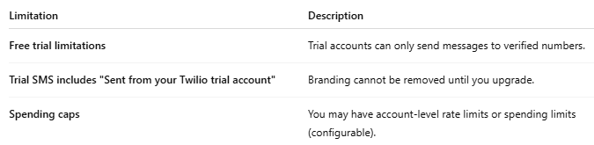

Limitation | Description
Free trial limitations | Trial accounts can only send messages to verified numbers.
Trial SMS includes "Sent from your Twilio trial account" | Branding cannot be removed until you upgrade.
Spending caps | You may have account-level rate limits or spending limits (configurable).

📌 3. Technical Limitations
# Source: AI Source: Provided by: [Data Path: Persons Table -> ID Column: 1, Name_En Column: Motasem Essam] -> From: [Chatgpt (GPT‑5 Mini)] on [1/21/2026]
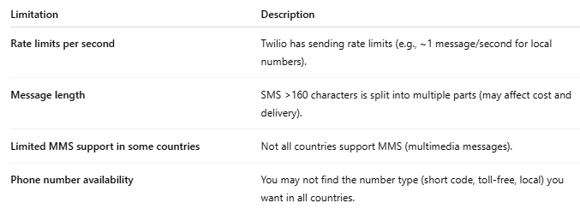

Limitation | Description
Rate limits per second | Twilio has sending rate limits (e.g., ~1 message/second for local numbers).
Message length | SMS >160 characters is split into multiple parts (may affect cost and delivery).
Limited MMS support in some countries | Not all countries support MMS (multimedia messages).
Phone number availability | You may not find the number type (short code, toll-free, local) you want in all countries.

📌 4. Compliance & Regulations
# Source: AI Source: Provided by: [Data Path: Persons Table -> ID Column: 1, Name_En Column: Motasem Essam] -> From: [Chatgpt (GPT‑5 Mini)] on [1/21/2026]
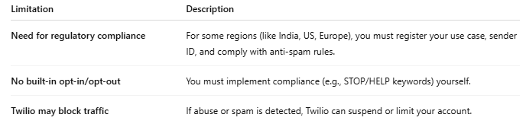

Limitation | Description
Need for regulatory compliance | For some regions (like India, US, Europe), you must register your use case, sender ID, and comply with anti-spam rules.
No built-in opt-in/opt-out | You must implement compliance (e.g., STOP/HELP keywords) yourself.
Twilio may block traffic | If abuse or spam is detected, Twilio can suspend or limit your account.

📌 5. Cost-Related Constraints
# Source: AI Source: Provided by: [Data Path: Persons Table -> ID Column: 1, Name_En Column: Motasem Essam] -> From: [Chatgpt (GPT‑5 Mini)] on [1/21/2026]
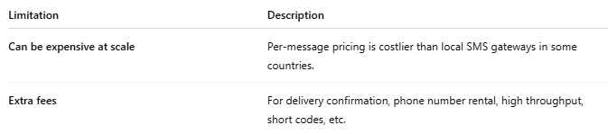

Limitation | Description
Can be expensive at scale | Per-message pricing is costlier than local SMS gateways in some countries.
Extra fees | For delivery confirmation, phone number rental, high throughput, short codes, etc.

📌 6. Developer Dependency
# Source: AI Source: Provided by: [Data Path: Persons Table -> ID Column: 1, Name_En Column: Motasem Essam] -> From: [Chatgpt (GPT‑5 Mini)] on [1/21/2026]
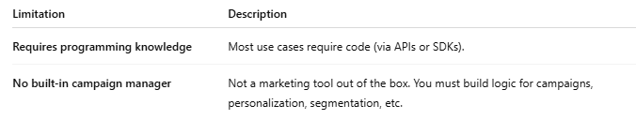
Limitation | Description
Requires programming knowledge | Most use cases require code (via APIs or SDKs).
No built-in campaign manager | Not a marketing tool out of the box. You must build logic for campaigns, personalization, segmentation, etc.

✅ Summary: Twilio is best when you need…
# Source: AI Source: Provided by: [Data Path: Persons Table -> ID Column: 1, Name_En Column: Motasem Essam] -> From: [Chatgpt (GPT‑5 Mini)] on [1/21/2026]
- Global reach with APIs
- Custom app integration
- 2FA / OTP services
- Reliable transactional messaging
But for simple marketing/bulk SMS, local gateways or platforms like Textlocal, Clickatell, or MSG91 may be easier and cheaper in some countries.

💡 Twilio Free vs. Paid Services
# Source: AI Source: Provided by: [Data Path: Persons Table -> ID Column: 1, Name_En Column: Motasem Essam] -> From: [Chatgpt (GPT‑5 Mini)] on [1/21/2026]
Twilio offers both Free Trial and Paid (Upgraded) account services. Here's a detailed comparison:

🆓 Twilio Free Trial Account
# Source: AI Source: Provided by: [Data Path: Persons Table -> ID Column: 1, Name_En Column: Motasem Essam] -> From: [Chatgpt (GPT‑5 Mini)] on [1/21/2026]
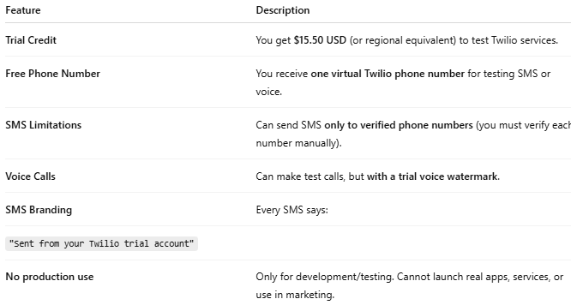

Feature | Description
Trial Credit | You get $15.50 USD (or regional equivalent) to test Twilio services.
Free Phone Number | You receive one virtual Twilio phone number for testing SMS or voice.
SMS Limitations | Can send SMS only to verified phone numbers (you must verify each number manually).
Voice Calls | Can make test calls, but with a trial voice watermark.
SMS Branding | Every SMS says:
"Sent from your Twilio trial account"
No production use | Only for development/testing. Cannot launch real apps, services, or use in marketing.

💰 Twilio Paid (Upgraded) Account
# Source: AI Source: Provided by: [Data Path: Persons Table -> ID Column: 1, Name_En Column: Motasem Essam] -> From: [Chatgpt (GPT‑5 Mini)] on [1/21/2026]
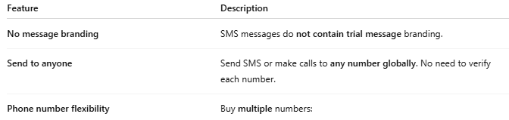

Feature | Description
No message branding | SMS messages do not contain trial message branding.
Send to anyone | Send SMS or make calls to any number globally. No need to verify each number.
Phone number flexibility | Buy multiple numbers:
- Local
- Toll-Free
- Short codes (high-volume) |
| Higher limits | Higher rate limits, throughput, and daily sending caps. |
| Access to premium features | Full access to:
- Twilio Verify (2FA/OTP)
- Twilio Conversations
- Twilio Studio (Visual Builder)
- WhatsApp API
- Email via SendGrid |
| Support SLAs | Priority support, SLAs, and usage analytics (for large accounts). |

💳 How to Upgrade from Free to Paid
# Source: AI Source: Provided by: [Data Path: Persons Table -> ID Column: 1, Name_En Column: Motasem Essam] -> From: [Chatgpt (GPT‑5 Mini)] on [1/21/2026]
- Log in to Twilio Console
- Click Billing > Upgrade
- Add a credit card and select usage limits
- Balance becomes "pay-as-you-go" — you’ll be charged based on actual use

📈 Pricing Example (USA, may vary)
# Source: AI Source: Provided by: [Data Path: Persons Table -> ID Column: 1, Name_En Column: Motasem Essam] -> From: [Chatgpt (GPT‑5 Mini)] on [1/21/2026]
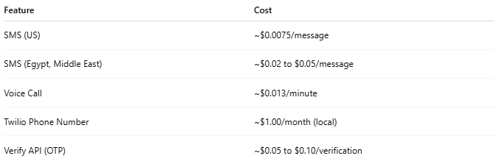

Feature | Cost
SMS (US) | ~$0.0075/message
SMS (Egypt, Middle East) | ~$0.02 to $0.05/message
Voice Call | ~$0.013/minute
Twilio Phone Number | ~$1.00/month (local)
Verify API (OTP) | ~$0.05 to $0.10/verification
💬 Tip: Use Twilio Pricing to check country-specific costs.

✅ Summary Table
# Source: AI Source: Provided by: [Data Path: Persons Table -> ID Column: 1, Name_En Column: Motasem Essam] -> From: [Chatgpt (GPT‑5 Mini)] on [1/21/2026]
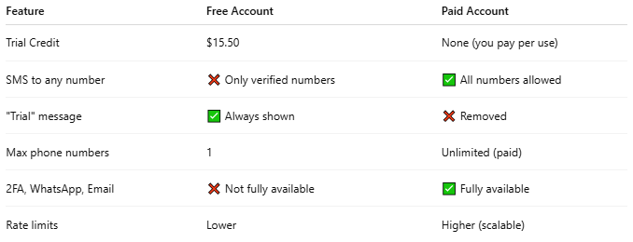

Feature | Free Account | Paid Account
Trial Credit | $15.50 | None (you pay per use)
SMS to any number | ❌ Only verified numbers | ✅ All numbers allowed
"Trial" message | ✅ Always shown | ❌ Removed
Max phone numbers | 1 | Unlimited (paid)
2FA, WhatsApp, Email | ❌ Not fully available | ✅ Fully available
Rate limits | Lower | Higher (scalable)

